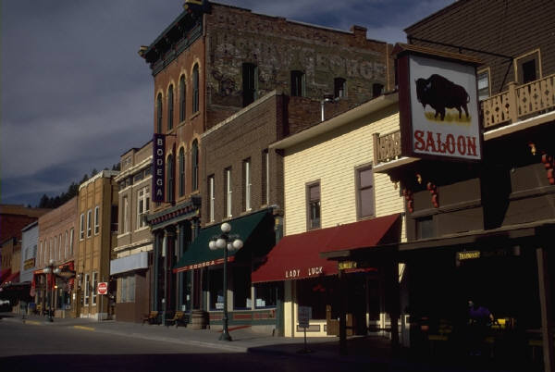

Grover’s Corner, New Hampshire
Constructing a Map

Directions: After reading the first part of Our Town, you will be required to draw and construct a map of Grover’s Corner. Try your best to follow the reading and formulate a map that would accurately depict the town. Your map must be colored and labeled with the places that were talked about in the beginning of the play. The assignment is worth 20 points. To receive full credit, you must follow all of the directions above.

Grover’s Corner, New Hampshire
Constructing a Map

Directions: After reading the first part of Our Town, you will be required to draw and construct a map of Grover’s Corner. Try your best to follow the reading and formulate a map that would accurately depict the town. Your map must be colored and labeled with the places that were talked about in the beginning of the play. The assignment is worth 20 points. To receive full credit, you must follow all of the directions above.

Grover’s Corner, New Hampshire
Constructing a Map

Directions: After reading the first part of Our Town, you will be required to draw and construct a map of Grover’s Corner. Try your best to follow the reading and formulate a map that would accurately depict the town. Your map must be colored and labeled with the places that were talked about in the beginning of the play. The assignment is worth 20 points. To receive full credit, you must follow all of the directions above.

